MBEYA UNIVERSITY OF SCIENCE AND TECHNOLOGY
COLLEGE OF ENGINEERING AND TECHNOLOGY

DEPARTMENT OF ELECTRICAL AND ELECTRONICS, TELECOM MECH ENGINEERINGA ND TECH EDUCATION
TECHNICAL DRAWING &ENGINEERING DRAWING
SUBMISSION DATE: 29th DEC, 2022 TIME 9.00AM
INSTRUCTIONS
- Answer ALL questions
- Draw the title block on each answer sheet (s)
- Construction lines must be shown on all solution
- Unless otherwise stated dimensions are given in mm
Question one (5 marks)
- Construct a regular hexagon given the length side is 40mm 1marks
- Divide the line of 87mm length in 7 equal divisions. 1marks
- Construct 30⁰ and 60⁰ angles. 1marks
- Construct a parallel line having 50mm distance apart. 1marks
- Construct an equilateral triangle with sides 60mm long. 1marks
Question two: Copy the following isometric drawing below. (5 marks)
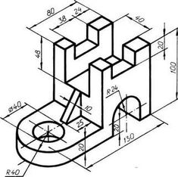
Question three: Copy the following isometric drawing below. (5 marks)
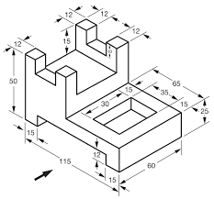
Question four: Copy the following geometric figure. (5 marks)
